Prueba Servicios

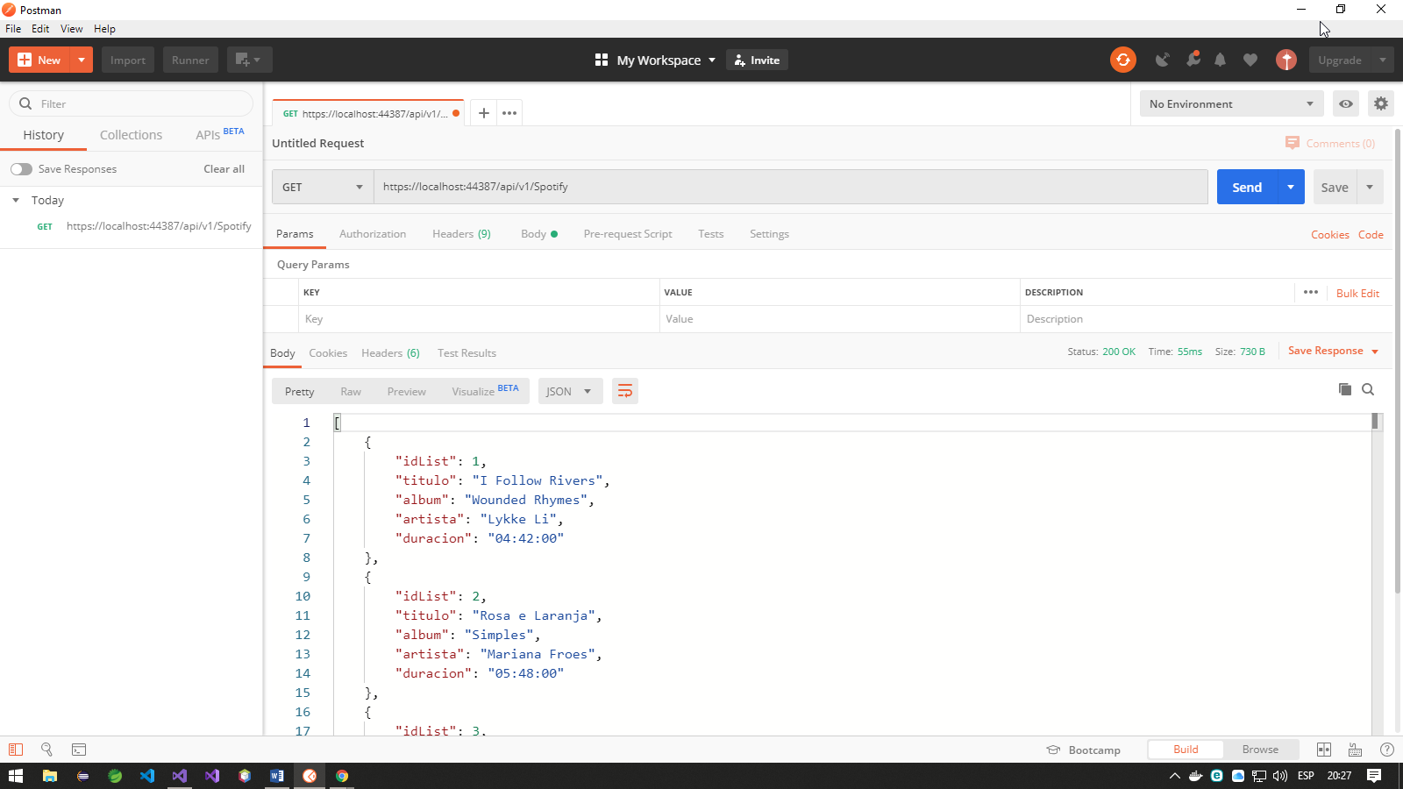https://**{localhost:44387}**/api/v1/Spotify (GET)

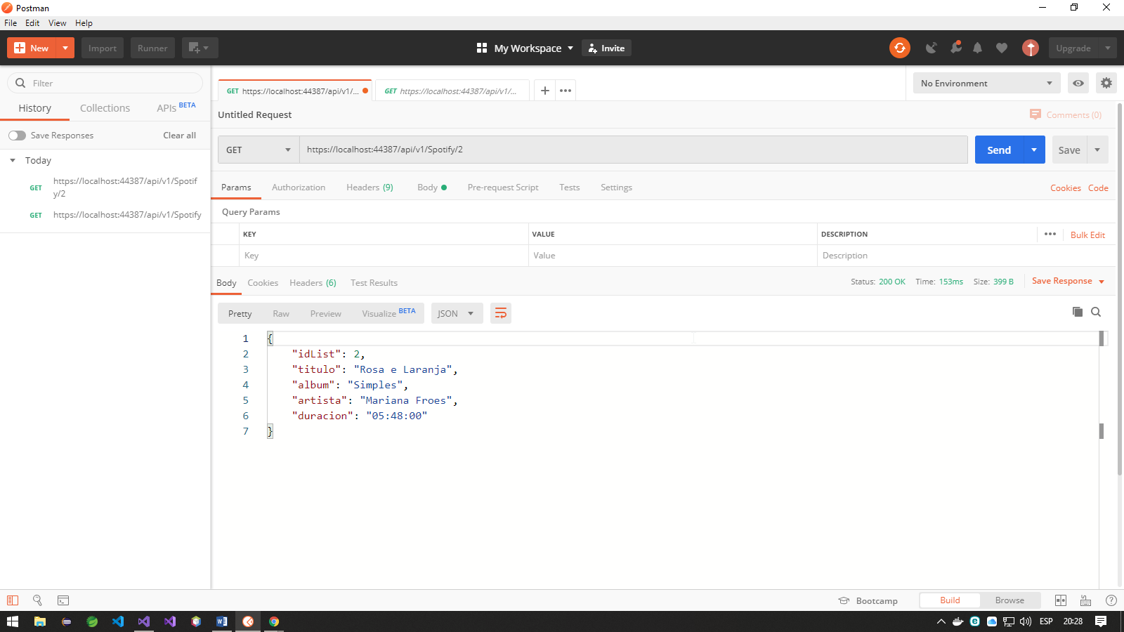https://**{localhost:44387}**/api/v1/Spotify/2 (GET)

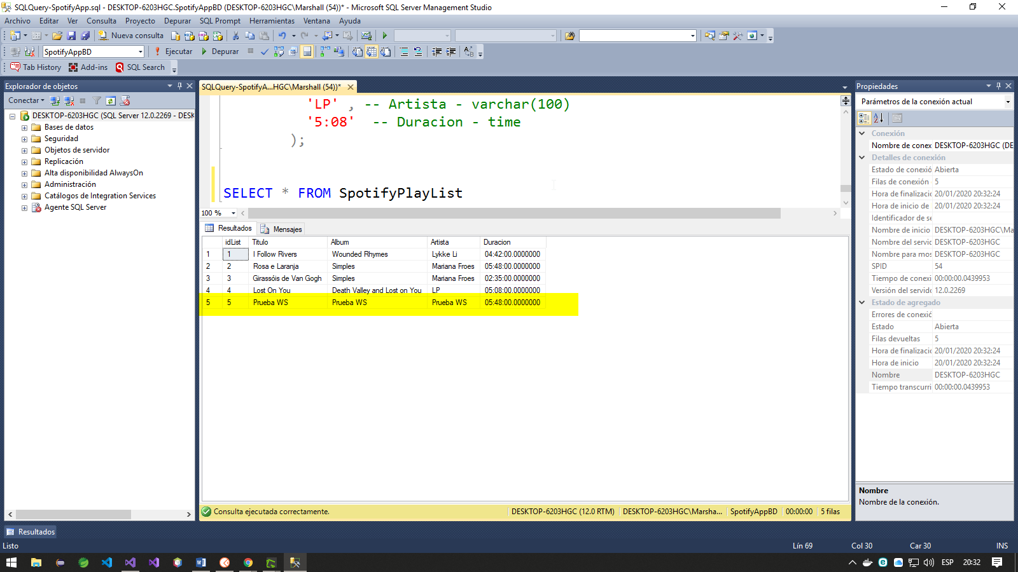<https://localhost:44387/api/v1/Spotify> (POST)

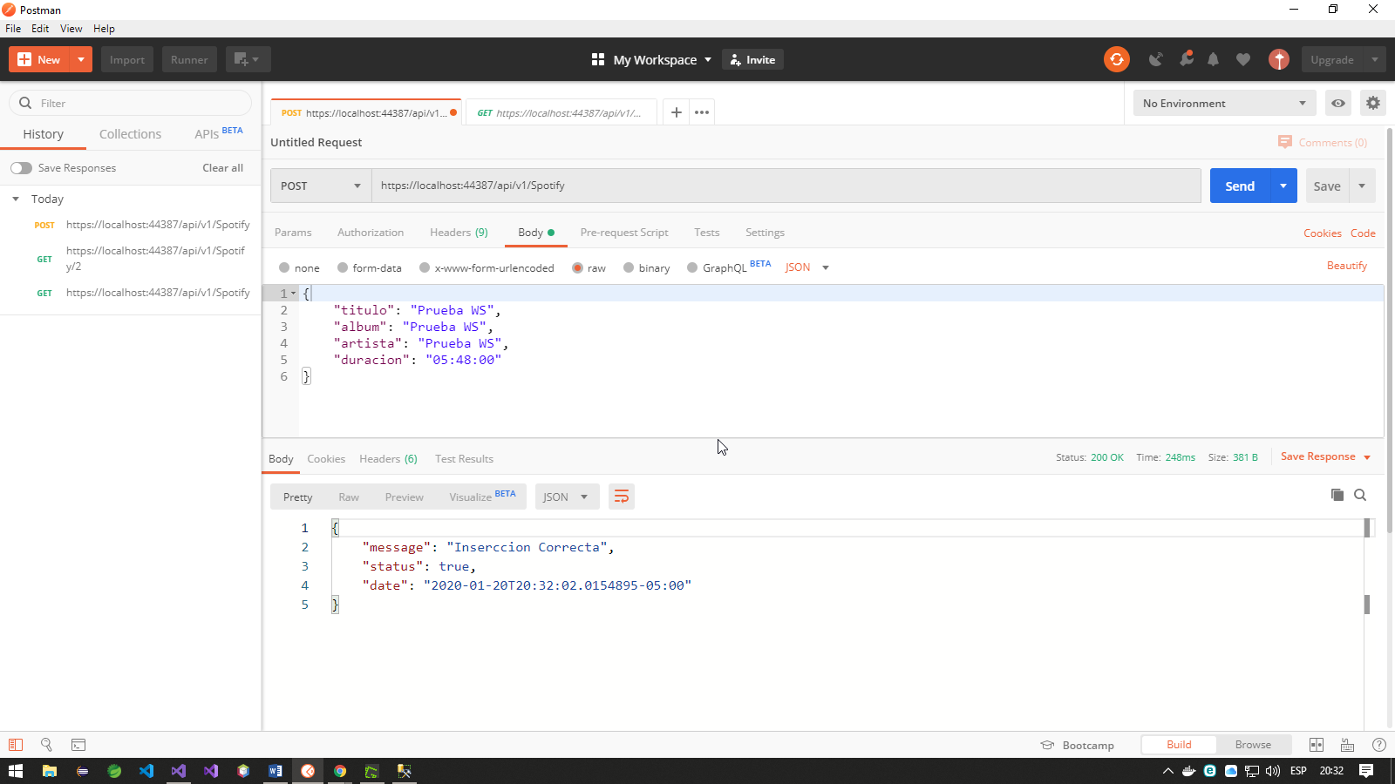

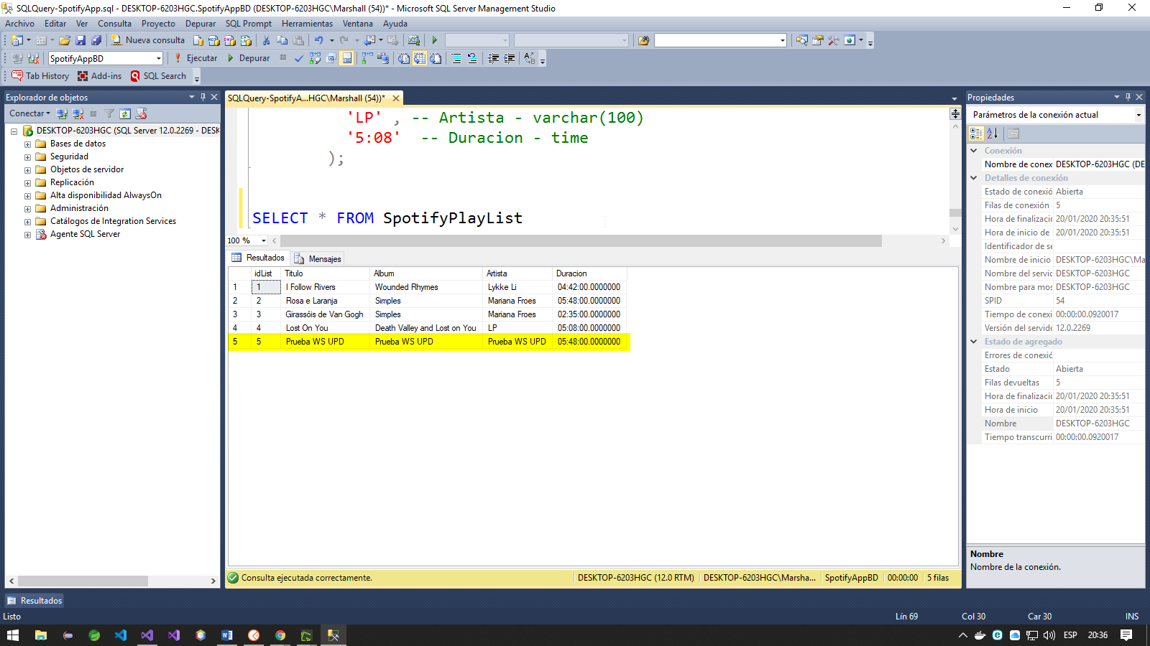<https://localhost:44387/api/v1/Spotify/5> (PUT)

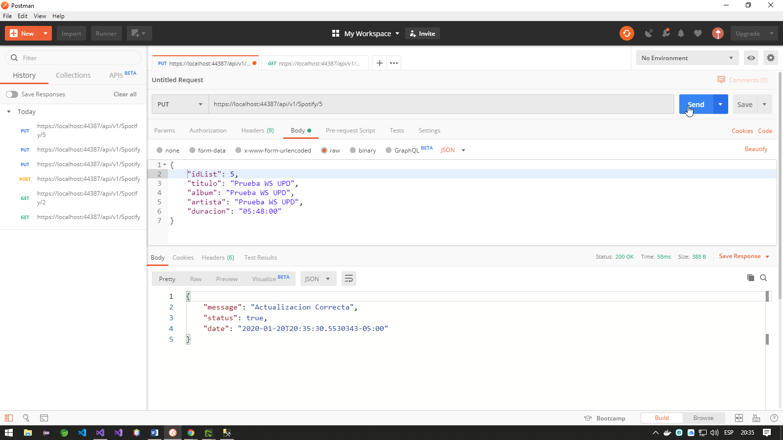

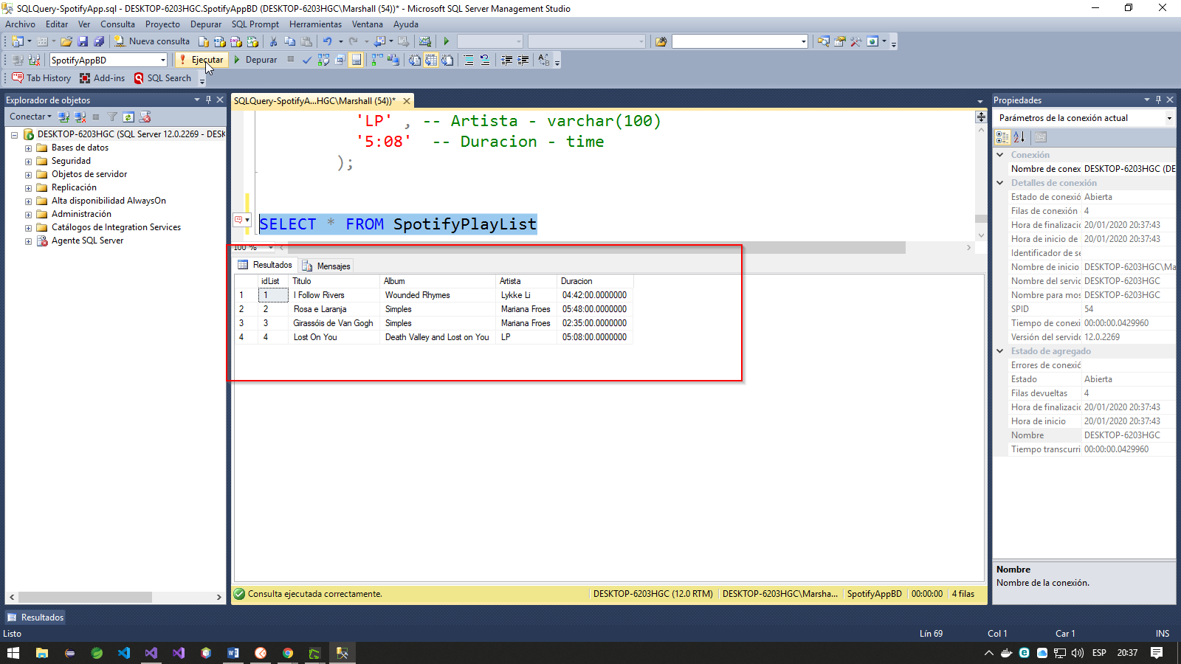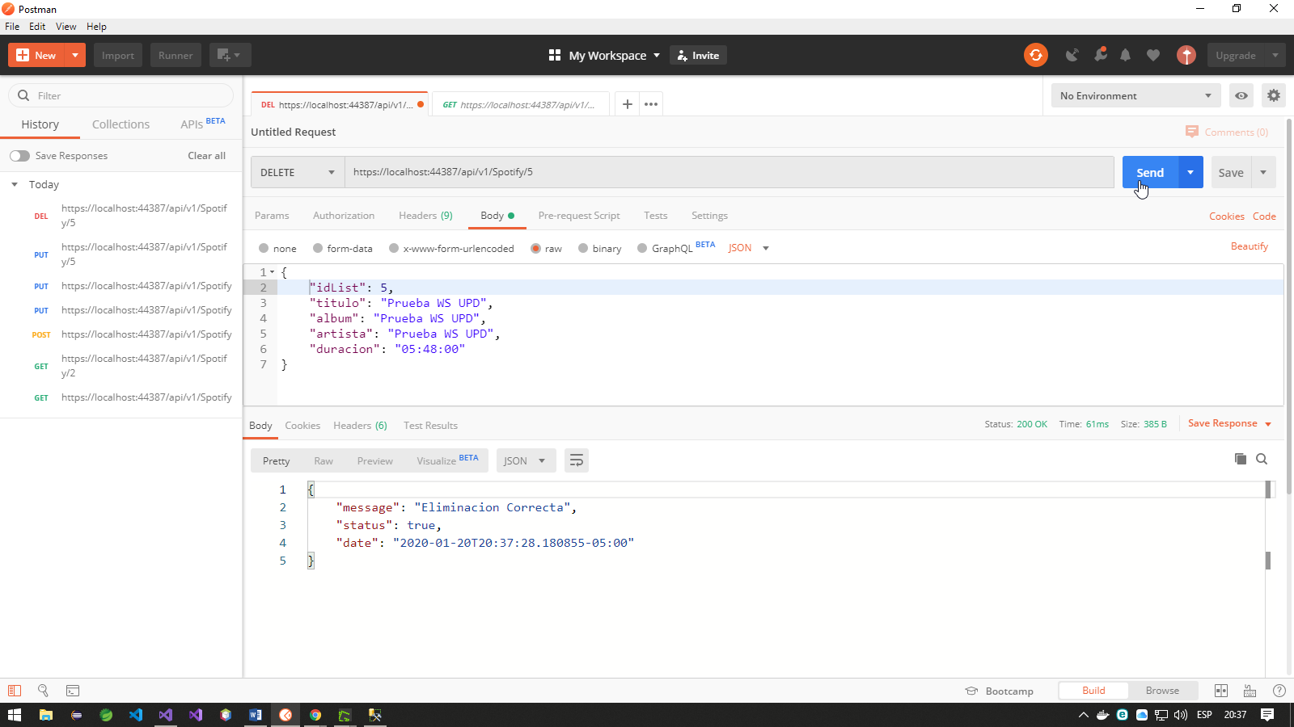<https://localhost:44387/api/v1/Spotify/5> (DELETE)